- Perform inner join, Left join, and Right join on the tables.
Inner Join
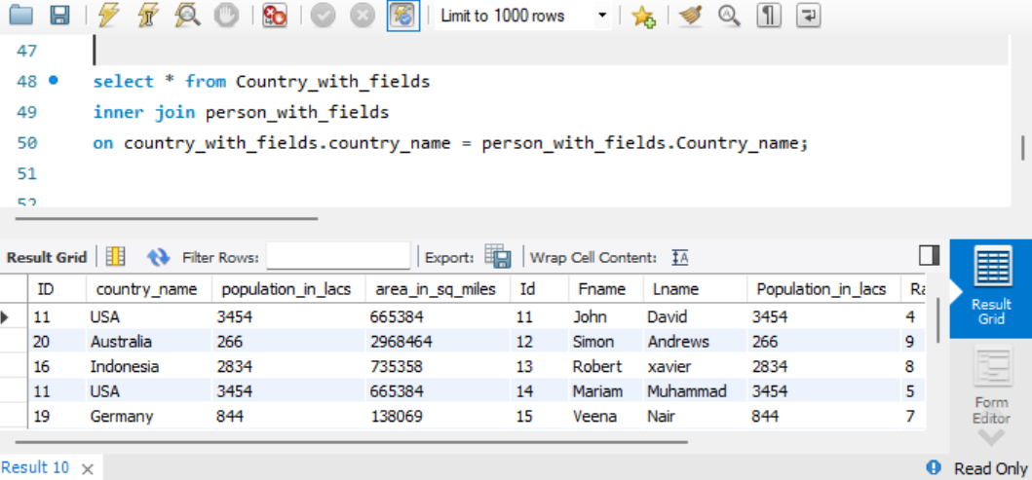

Left Join
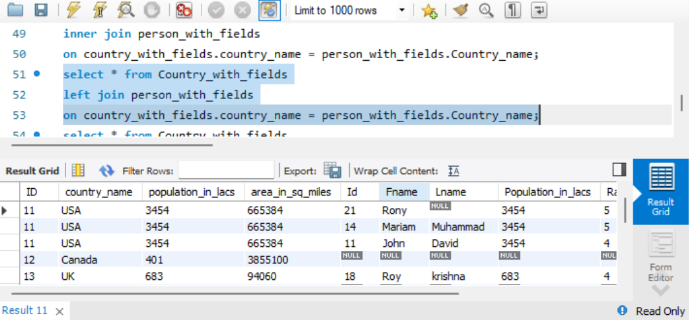

Right Join
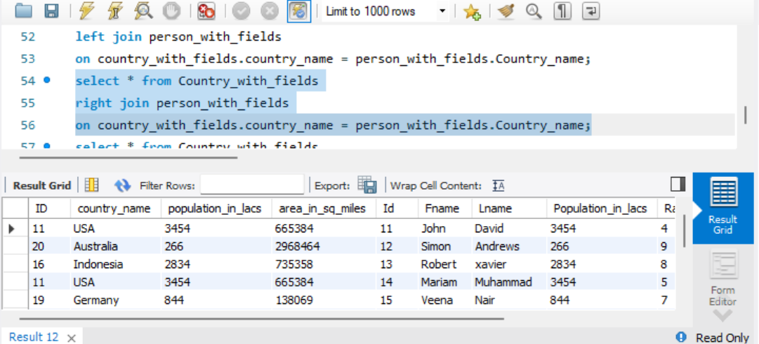

- List all distinct country names from both the Country and Persons tables.
distinct country names in Country table
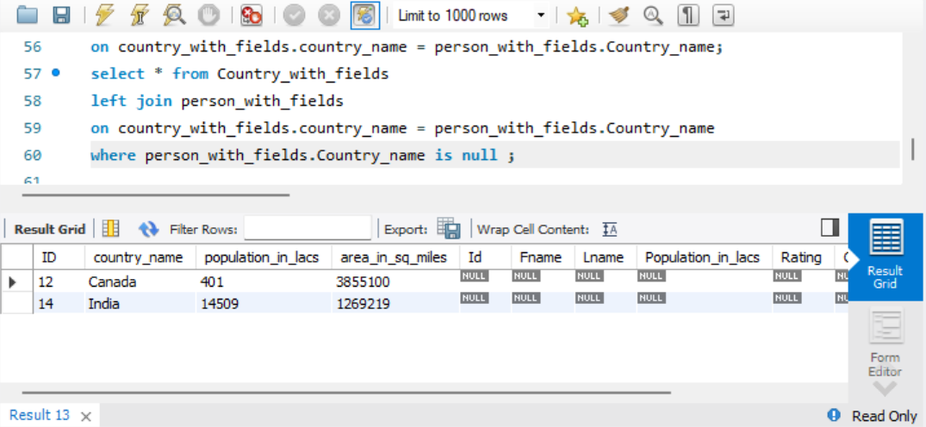
distinct country names in person table
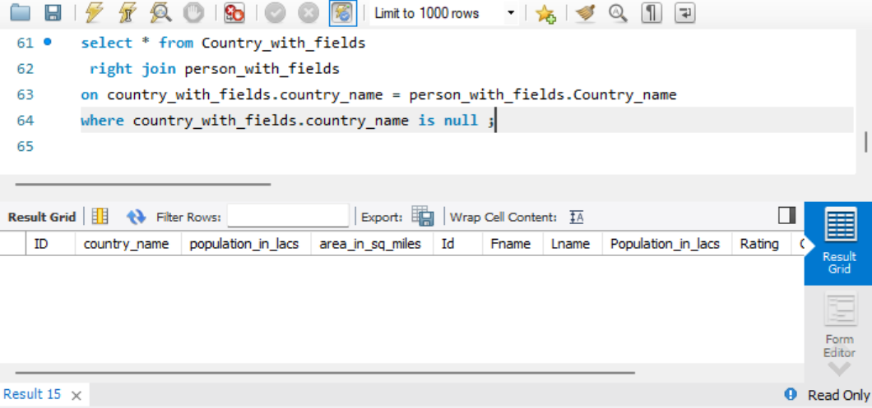

- List all country names from both the Country and Persons tables, including duplicates.
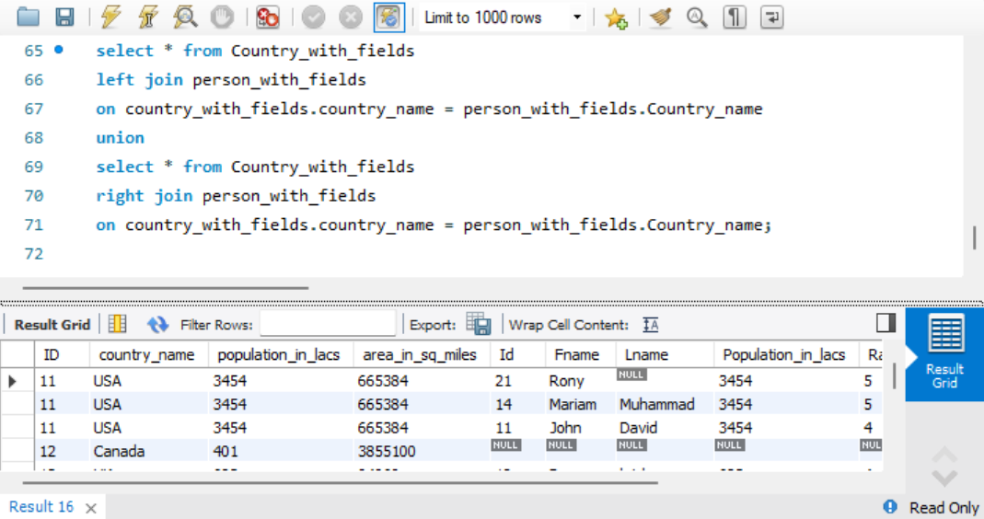
- Round the ratings of all persons to the nearest integer in the Persons table.
